🌱 What is ORM? (Object Relational Mapping)

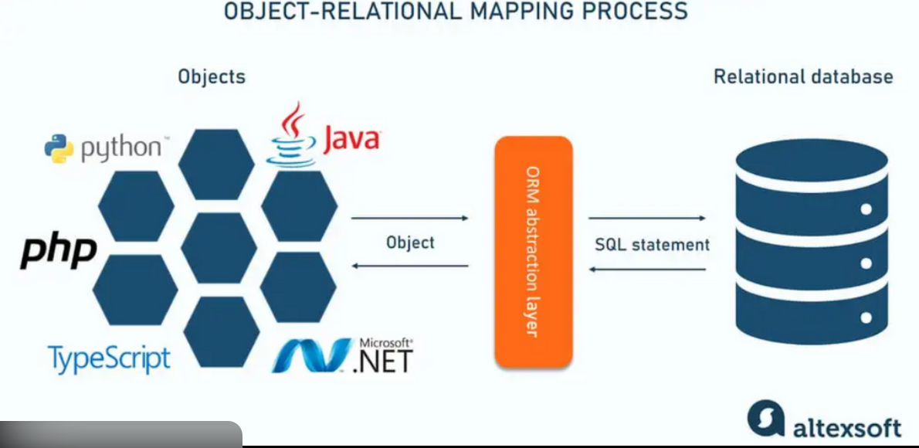

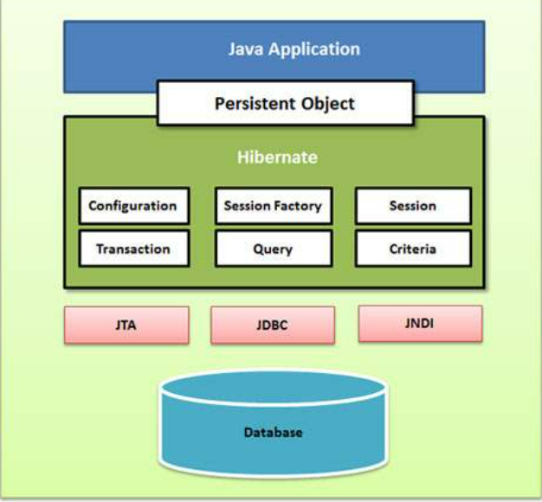

🔹 Simple Meaning
ORM is a technique that connects Java objects with database tables automatically.
👉 Instead of writing SQL queries manually,
👉 you work with Java classes and objects,
👉 and ORM converts them into SQL behind the scenes.

🔹 Without ORM (Old Style – JDBC)
INSERT INTO employee VALUES (1, 'Ravi', 30000);
You must:
- Write SQL
- Manage ResultSet
- Handle database mapping manually

🔹 With ORM (Modern Style)
Employee emp = new Employee(1, "Ravi", 30000);
entityManager.persist(emp);
✔ No SQL
✔ No ResultSet
✔ No manual mapping
ORM automatically:
- Converts object → SQL
- Executes query
- Stores data in DB

🔹 Real-World Analogy
📦 Courier Service Example
- You give a parcel (Java object)
- Courier company (ORM) handles:
  - Packing
  - Transport
  - Delivery (DB insert/update)
You don’t care how it travels.

✅ Advantages of ORM (Why We Use It)
1️⃣ Less SQL Code
- No need to write repeated SQL queries
- Cleaner Java code

2️⃣ Faster Development
- Developers focus on business logic
- ORM handles DB operations

3️⃣ Database Independent
- Change DB from MySQL → Oracle → H2
- Code remains mostly the same

4️⃣ Object-Oriented Programming
- Tables → Java classes
- Rows → Objects
- Columns → Fields
Feels natural for Java developers ☕

5️⃣ Built-in Features
- Caching
- Lazy loading
- Transactions
- Relationship handling (@OneToMany, etc.)

🌱 What is JPA?
🔹 Definition
Java Persistence API (JPA) is a specification (rules + interfaces) for ORM in Java.
📌 Important:
JPA is NOT a tool
JPA is NOT an implementation
JPA is a standard

🔹 Think Like This
📜 JPA = Rule Book
🛠 Hibernate = Tool that follows the rules

🔹 What JPA Defines
JPA defines:
- Annotations (@Entity, @Id, @Table)
- Interfaces (EntityManager)
- ORM behavior rules
But does NOT give actual working code.

🔹 Example JPA Annotation
@Entity
@Table(name = "employee")
public class Employee {

@Id
private int id;

private String name;
private double salary;
}
👆 This is JPA standard code

🌱 What is Hibernate?
🔹 Definition
Hibernate is an ORM framework and a JPA implementation.
✔ Hibernate implements JPA
✔ Hibernate does the real work
✔ Hibernate generates SQL internally

🔹 Hibernate Can Work In 2 Ways
1️⃣ Using Hibernate Native API
2️⃣ Using JPA API (most common) ✅

🔹 Hibernate Extra Features
Hibernate provides:
- Second-level cache
- HQL (Hibernate Query Language)
- Criteria API
- Better performance optimizations

⚔️ JPA vs Hibernate (Very Important)
Feature | JPA | Hibernate
Type | Specification | Implementation
Is it a framework? | ❌ No | ✅ Yes
Provides code? | ❌ No | ✅ Yes
Vendor-neutral | ✅ Yes | ❌ No
Extra features | ❌ Limited | ✅ Rich
Used directly? | ❌ Cannot | ✅ Can
Example | Rule Book | Working Tool

🔹 Simple Comparison
📘 JPA = Interface
🔧 Hibernate = Class that implements it
EntityManager em; // JPA
Session session; // Hibernate

🧠 Real-World Analogy (Best for Freshers)
🚗 Driving Example
- JPA → Driving Rules (Traffic rules)
- Hibernate → Car (Actual vehicle)
Rules alone won’t move you.
You need a car that follows the rules 🚘

🧩 How They Work Together in Spring Boot
Spring Boot
↓
JPA (Standard API)
↓
Hibernate (Implementation)
↓
Database (MySQL / Oracle / H2)
You write JPA code, Hibernate executes it.

✅ When to Use What?
✔ Use JPA
- For standard, clean, portable code
- Recommended for enterprise applications
✔ Use Hibernate features
- When you need advanced performance tuning
- Caching, batch processing, custom queries

🎯 Final Summary
- ORM → Maps Java objects to DB tables
- JPA → Specification (rules)
- Hibernate → ORM framework + JPA implementation
- Spring Boot uses JPA + Hibernate internally

Spring Boot + JPA + Hibernate + H2 (Beginner Friendly)
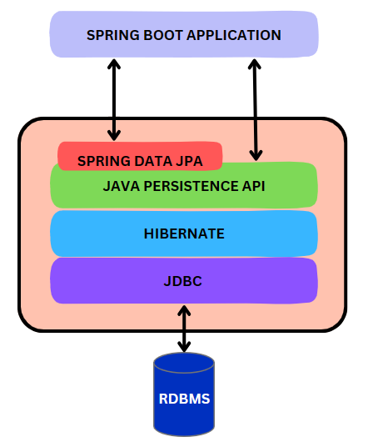
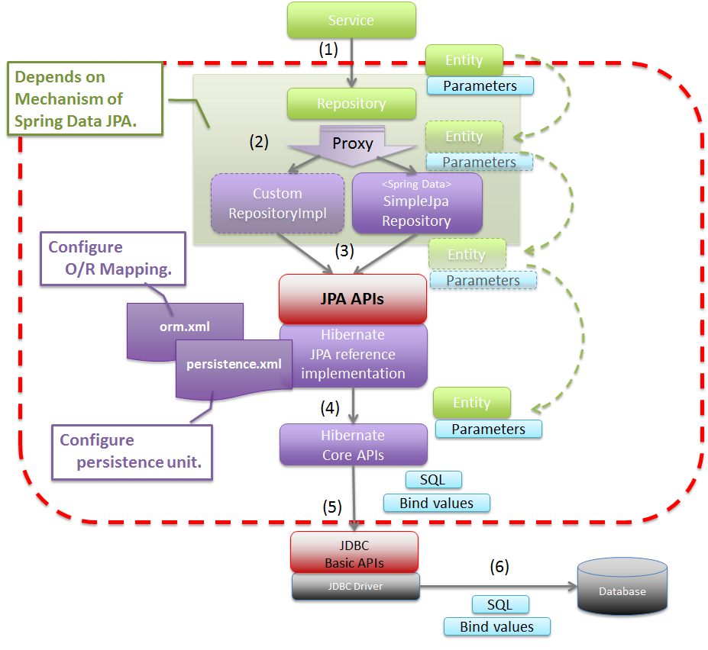
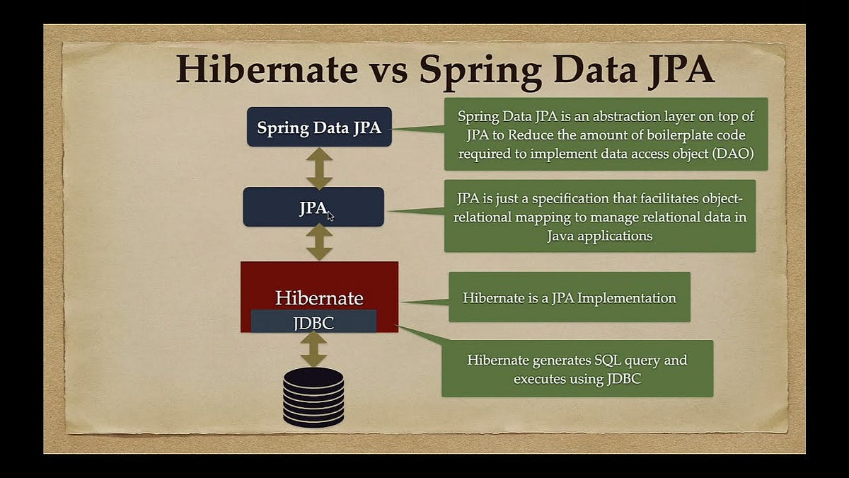

🧠 What We Are Building (Before Coding)
🎯 Goal
A small application to:
- Save an Employee
- Fetch all Employees
- Use JPA annotations
- Let Hibernate generate SQL
- Use H2 in-memory database

🛠 Tools Required
- STS / IntelliJ
- Java 17+
- Maven
- Spring Boot

STEP 1️⃣ – Create Spring Boot Project
Choose:
- Project: Maven
- Language: Java
- Packaging: Jar
- Java: 17
Add Dependencies:
✔ Spring Web
✔ Spring Data JPA
✔ H2 Database

STEP 2️⃣ – pom.xml (Dependencies Explained)
<dependencies>

<!-- Spring Web -->
<dependency>
<groupId>org.springframework.boot</groupId>
<artifactId>spring-boot-starter-web</artifactId>
</dependency>

<!-- Spring Data JPA -->
<dependency>
<groupId>org.springframework.boot</groupId>
<artifactId>spring-boot-starter-data-jpa</artifactId>
</dependency>

<!-- H2 Database -->
<dependency>
<groupId>com.h2database</groupId>
<artifactId>h2</artifactId>
<scope>runtime</scope>
</dependency>

</dependencies>
💡 What is Happening?
- spring-boot-starter-data-jpa
👉 Brings JPA + Hibernate
- h2
👉 Lightweight in-memory DB (no installation)

STEP 3️⃣ – application.properties
# H2 database URL
spring.datasource.url=jdbc:h2:mem:testdb

spring.datasource.driverClassName=org.h2.Driver
spring.datasource.username=sa
spring.datasource.password=

# Hibernate settings
spring.jpa.database-platform=org.hibernate.dialect.H2Dialect
spring.jpa.hibernate.ddl-auto=update

# Show SQL in console
spring.jpa.show-sql=true

# Enable H2 Console
spring.h2.console.enabled=true
spring.h2.console.path=/h2-console
🔍 Explanation
Property | Meaning
ddl-auto=update | Hibernate creates tables automatically
show-sql=true | Prints SQL in console
h2-console | Browser-based DB view

STEP 4️⃣ – Create Entity Class (MOST IMPORTANT)
📁 com.example.demo.entity.Employee
package com.example.demo.entity;

import jakarta.persistence.Entity;
import jakarta.persistence.Id;
import jakarta.persistence.Table;

@Entity
@Table(name = "employee")
public class Employee {

@Id
private int id;

private String name;
private double salary;

public Employee() {
// Required by JPA
}

public Employee(int id, String name, double salary) {
this.id = id;
this.name = name;
this.salary = salary;
}

// getters & setters
}

🧠 What Each Annotation Does
Annotation | Purpose
@Entity | Tells JPA → This is a table
@Table | Table name
@Id | Primary Key
No SQL written | Hibernate auto-generates SQL

STEP 5️⃣ – Repository Layer (JPA Magic)
📁 com.example.demo.repository.EmployeeRepository
package com.example.demo.repository;

import org.springframework.data.jpa.repository.JpaRepository;
import com.example.demo.entity.Employee;

public interface EmployeeRepository
extends JpaRepository<Employee, Integer> {
}
🤯 Why This Is Powerful
- No implementation class
- No SQL
- Spring creates code at runtime
You automatically get:
- save()
- findAll()
- findById()
- deleteById()

STEP 6️⃣ – Service Layer (Business Logic)
📁 com.example.demo.service.EmployeeService
package com.example.demo.service;

import java.util.List;
import org.springframework.stereotype.Service;
import com.example.demo.entity.Employee;
import com.example.demo.repository.EmployeeRepository;

@Service
public class EmployeeService {

private final EmployeeRepository repo;

public EmployeeService(EmployeeRepository repo) {
this.repo = repo;
}

public Employee saveEmployee(Employee emp) {
return repo.save(emp);
}

public List<Employee> getAllEmployees() {
return repo.findAll();
}
}
🧠 Why Service Layer?
- Keeps controller clean
- Holds business logic
- Best practice in real projects

STEP 7️⃣ – Controller Layer (REST API)
📁 com.example.demo.controller.EmployeeController
package com.example.demo.controller;

import java.util.List;
import org.springframework.web.bind.annotation.*;
import com.example.demo.entity.Employee;
import com.example.demo.service.EmployeeService;

@RestController
@RequestMapping("/employees")
public class EmployeeController {

private final EmployeeService service;

public EmployeeController(EmployeeService service) {
this.service = service;
}

@PostMapping
public Employee addEmployee(@RequestBody Employee emp) {
return service.saveEmployee(emp);
}

@GetMapping
public List<Employee> getEmployees() {
return service.getAllEmployees();
}
}

STEP 8️⃣ – Main Class
@SpringBootApplication
public class OrmDemoApplication {

public static void main(String[] args) {
SpringApplication.run(OrmDemoApplication.class, args);
}
}

STEP 9️⃣ – Test Using Postman / Browser
🔹 POST Employee
POST http://localhost:8080/employees
{
"id": 1,
"name": "Arun",
"salary": 30000
}
🔹 GET Employees
GET http://localhost:8080/employees

STEP 🔟 – Observe Console Output (IMPORTANT)
You’ll see SQL like:
insert into employee (name, salary, id) values (?, ?, ?)
👉 Hibernate generated this automatically

STEP 1️⃣1️⃣ – H2 Console
Open browser:
http://localhost:8080/h2-console
Use:
- JDBC URL: jdbc:h2:mem:testdb
- Username: sa
You can see tables and data visually 👀

🔄 How ORM, JPA, Hibernate Worked Together
Controller
↓
Service
↓
JPA Repository (Standard API)
↓
Hibernate (Implementation)
↓
H2 Database

🎯 Interview-Friendly Summary
✔ ORM → Object to table mapping
✔ JPA → Standard API
✔ Hibernate → ORM framework
✔ Spring Boot → Auto configuration
✔ H2 → In-memory DB for testing

